**Green Society Public School**

**D-24**

**Ratnanagar-7, Sauraha, Chitwan**

**First Term Examination -2082**

**Class: 4 Time: 2 hrs. F.M.:50**

**Sub: Maths**

1. **Construct an angle ∠ABC where,**
2. The angle ∠ABC= 60°. [2]
3. Name the vertex of the angle formed. [1]
4. Name the arms of angle. [2]
5. **Ram wants to buy a car. If the cost of a car is 40,79,308. Then,**

|  |  |  |  |  |  |  |
| --- | --- | --- | --- | --- | --- | --- |
| Ten Lakh | Lakh | Ten Thousand | Thousand | Hundred | Tens | ones |
|  |  |  |  |  |  |  |

1. Complete the given number table. [2]
2. Write the number name of the car’s price. [1]
3. Also write the car’s price in expanded form. [2]
4. **If the population of Bagmati province is *6084042* and the population of Karnali is *1694889*.**
5. Rewrite the population of Bagmati province and Karnali province using national number system. [2]
6. Compare the population of both provinces. [1]
7. Find the sum of the population of both provinces. [2]
8. **Write the answers to the following:**
9. 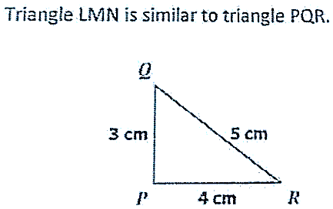Classify the following angles – (Acute angle, Right angle, Obtuse angle, Straight Angle) [2]

900, 500, 1800, 1200

1. Find the perimeter of given triangle. [2]
2. **Can you complete the given patterns?**
3. 1, 4, 7, 10, ___, 16, ___ [1]
4. 110, 90, ____, ___,30 [1]
5. 22, 33, 44, ___, ___ 77 [1]
6. 1100,1000, ____, 800, ____ [1]
7. **Answer the following:**
8. Construct an angle of 900 by the help of protractor. [2]
9. Do as indicated: [2]
10. ii.

Days Hours

8 10

+ 4 7

Months Days

16 28

- 9 10

1. **Complete the given bill:** [5]

|  |  |  |  |  |
| --- | --- | --- | --- | --- |
| **XYZ Fashion**  **New Road, Kathmandu** | | | | |
| **S. No** | **Name of Article** | **Quantity** | **Rate (Rs.)** | **Amount** |
|  | Pen | 4 | 10 | ________ |
|  | Textbook | 2 | 80 | ________ |
|  | Notebook | 8 | 40 | ________ |
| **Total** | | | | **Rs**. ______ |
| **In word**: ______________________________________. | | | | |

D

1. **Look at the diagram given and do as indicate:** [5]

2.5 cm

C

2.5 cm cm

1. AB + BC = _____

B

1. BC + CD = _____

3 cm

A

1. AC = _____
2. AC – BC = _____

2 cm

1. AD = _____
2. **Ram wants to buy a bicycle. A shopkeeper shows Ram a bicycle for Rs. 9085.**
3. Rewrite the cost of bike in Devanagari numeral. [1]
4. Also write cost of the bicycle in Devanagari. [1]
5. Write the place value of the underlined digit. [1]
6. If Ram gives Rs.10000 to the shopkeeper. How much money does the shopkeeper return to Ram? [2]
7. **Write the largest 6-digit numeral and the smallest 4-digit numeral.**  [2]
8. Find the sum of both numerals. [1]
9. Find the difference between numerals. [1]
10. **Complete the given number pattern:**
11. 6+5 = 5 = ___ [1]
12. 20 - ___ = 14 [1]
13. ___ - 12 = 8 [1]
14. 15 ÷ ___ = 3 [1]

☺ **BEST WISHES** ☺